LMS Data M6 Cage Nuts, Bolts and Washers Kit - for Rack Mount Equipment Installation on Network cabinets (50 Pack)
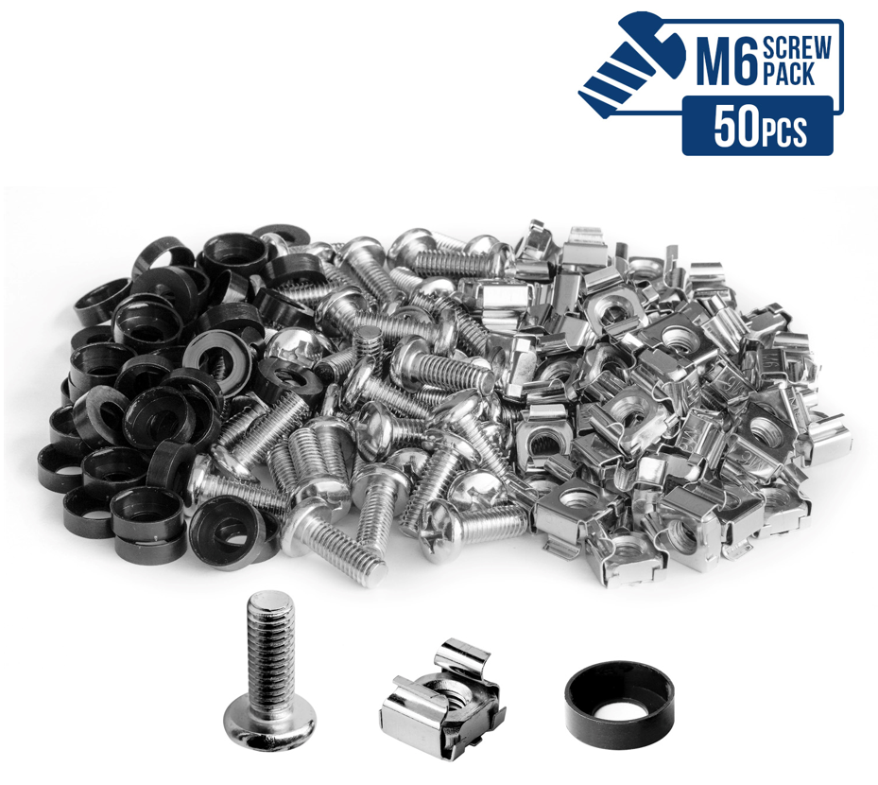

Note: This item is eligible for FREE Click and Collect without a minimum order subject to availability. Details

Item Package Quantity: 50

- ✔️ QUALITY The LMS Data NUTSCREWS-50 are a quality, alloy constructed, M6 universal sized fixing set that is ideal for attaching 19-inch devices such as Switches, Servers, UPS, Patch Panels and NAS devices into data cabinets from almost all vendors. Supplied in a cost saving 50-pack, they feature nylon washer that provides extra grip, especially for heavier rackmount devices while at the same time adding cushioning and helping to prevent over-tightening
- ✔️ STANDARD SIZE The M6 size is the standard size for network cabinets, server cabinets, wall cabinets, electronics casings, racks, shelves, patch panels, switches, fans and more.
- ✔️CONTAINS: 50x M6 bolts/screws, 50x captive cage nuts, 50x black plastic washers
- ✔️ PRACTICAL Cage nuts are suitable for integrated components in racks and cabinets like patch panels and switches or for network cabinets with similar mounting technology.
- ✔️ VALUE FOR MONEY The biggest M6 screw pack out there. With the LMS Data NUTSCREWS-50 you will be set for all your needs.

Manufacturer | ‎LMS Data
Package Dimensions | ‎18 x 5.5 x 5.3 cm; 464 Grams
Colour | ‎Sliver
Item Package Quantity | ‎50
Batteries included? | ‎No
Batteries Required? | ‎No
Item Weight | ‎464 g

- Part number: NUTSCREWS-50

